ADF Snaps
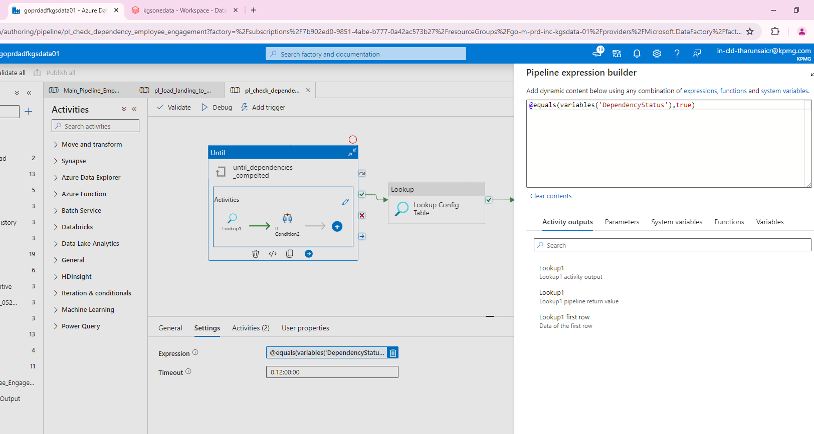
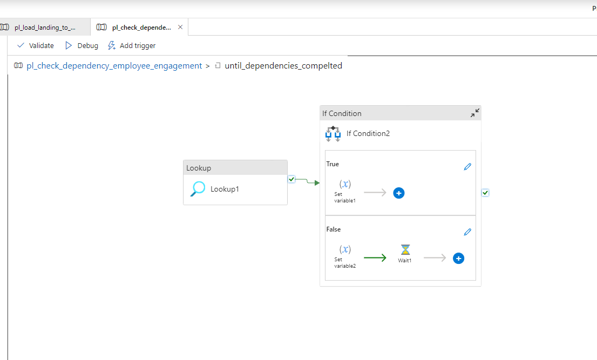
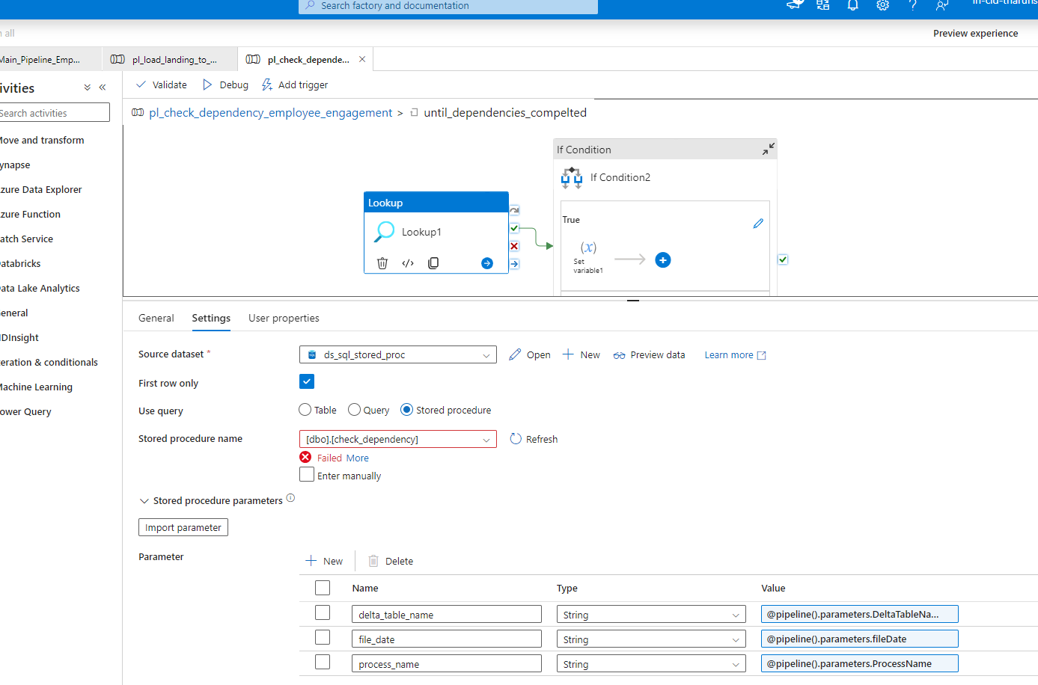
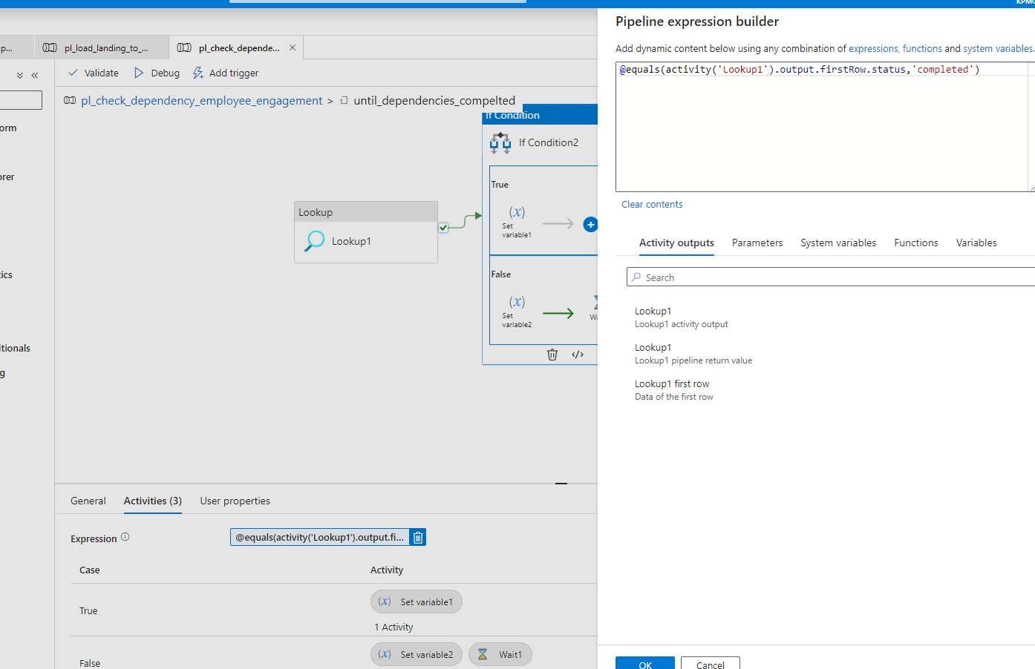
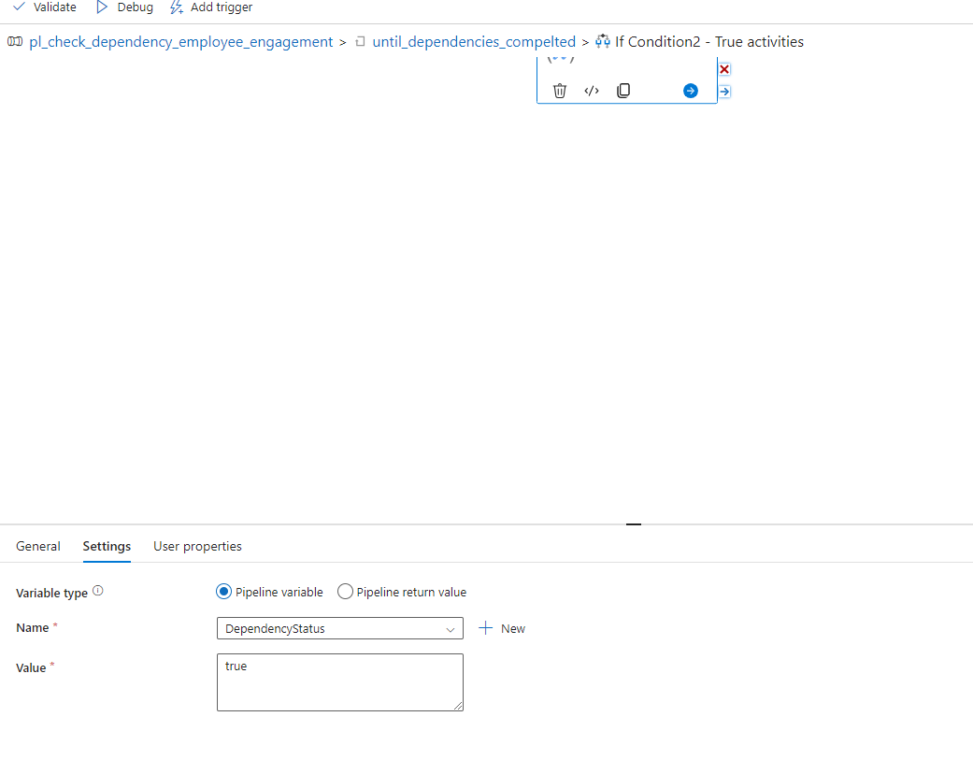
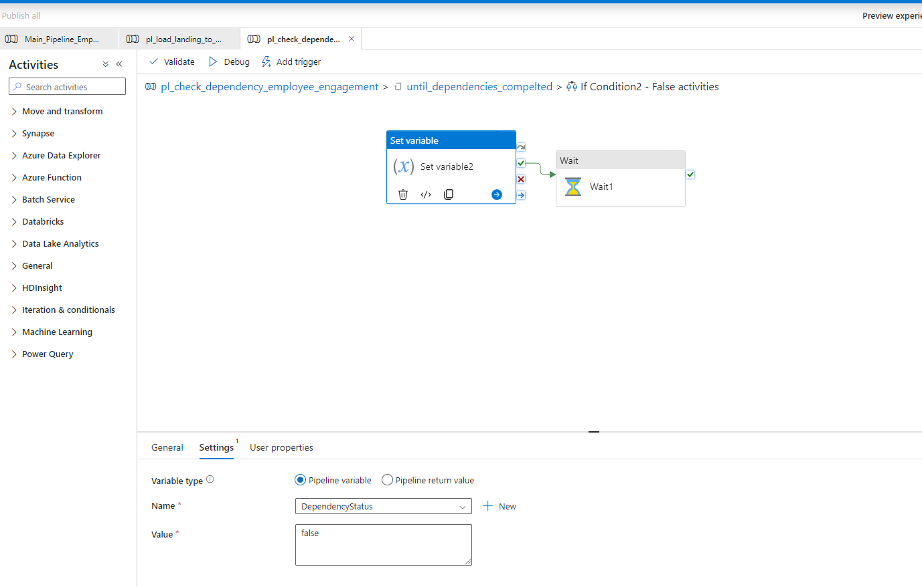
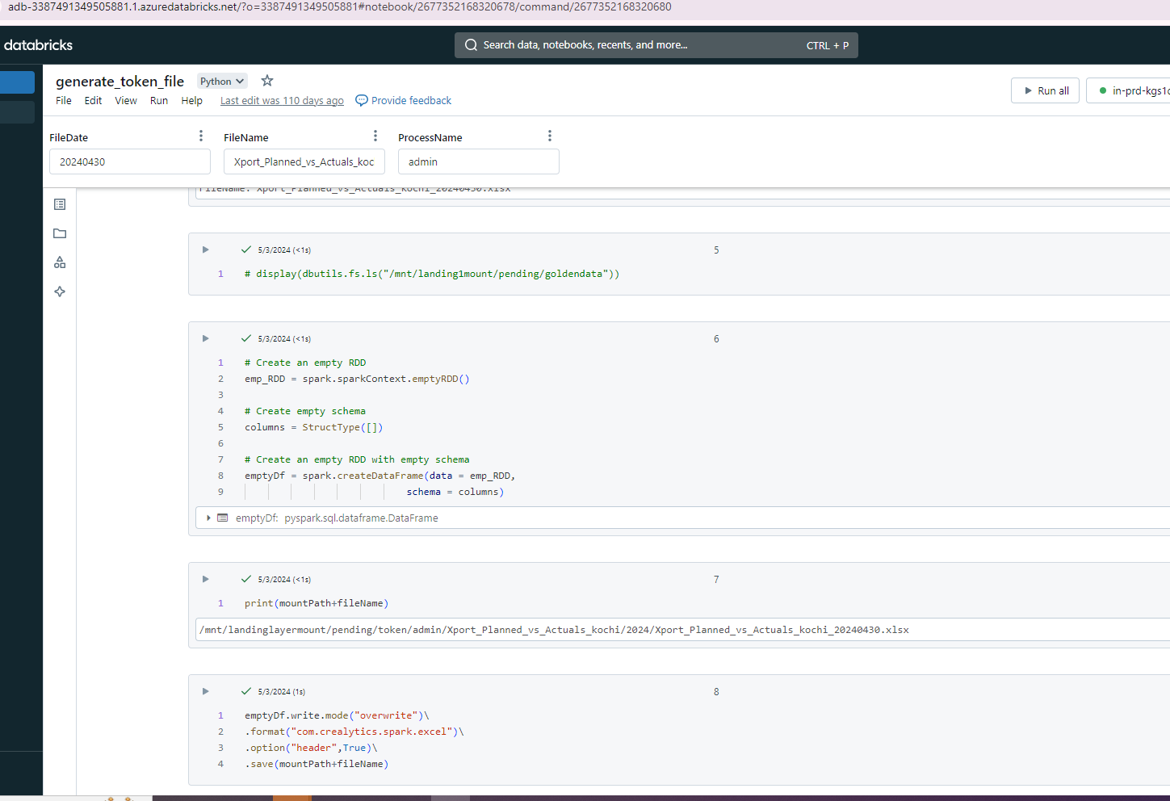
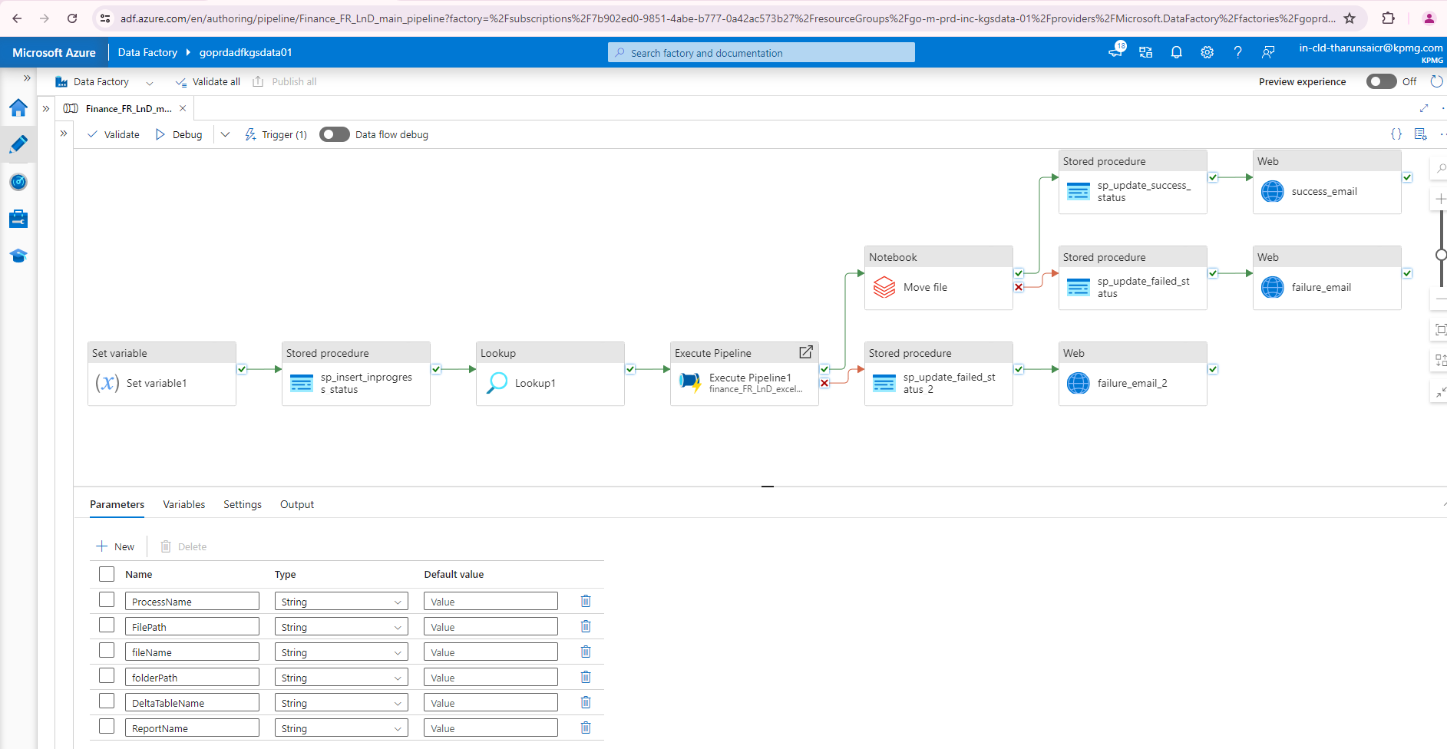
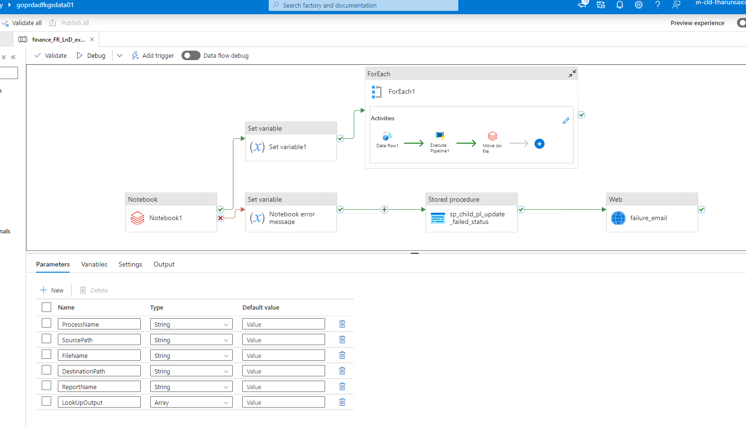
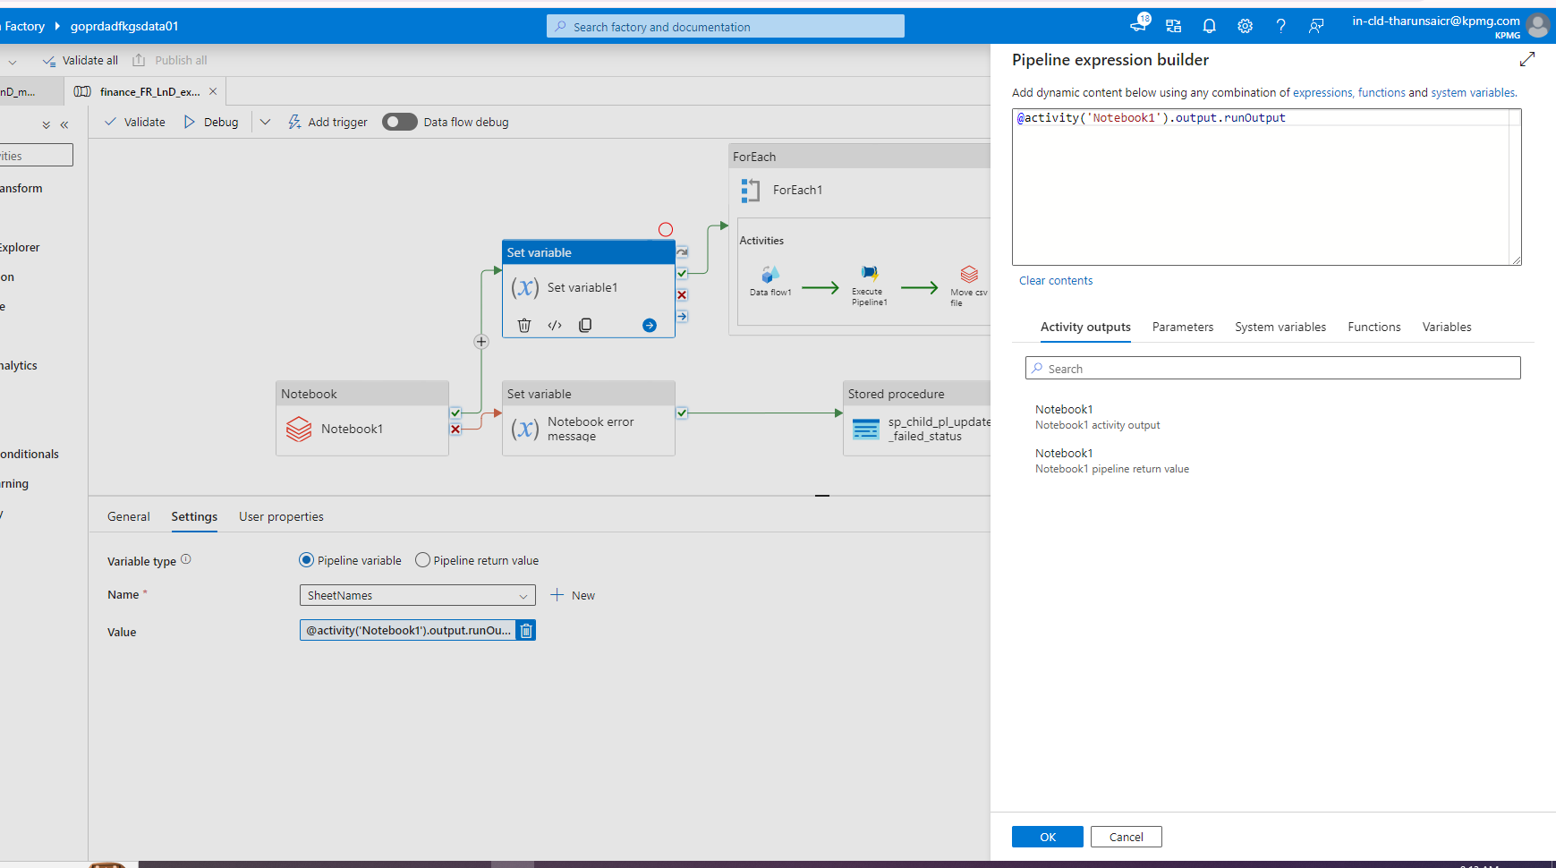
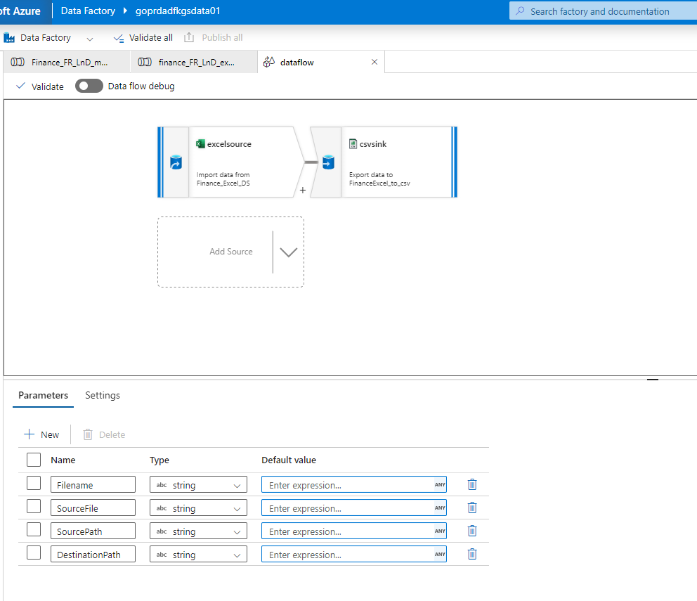
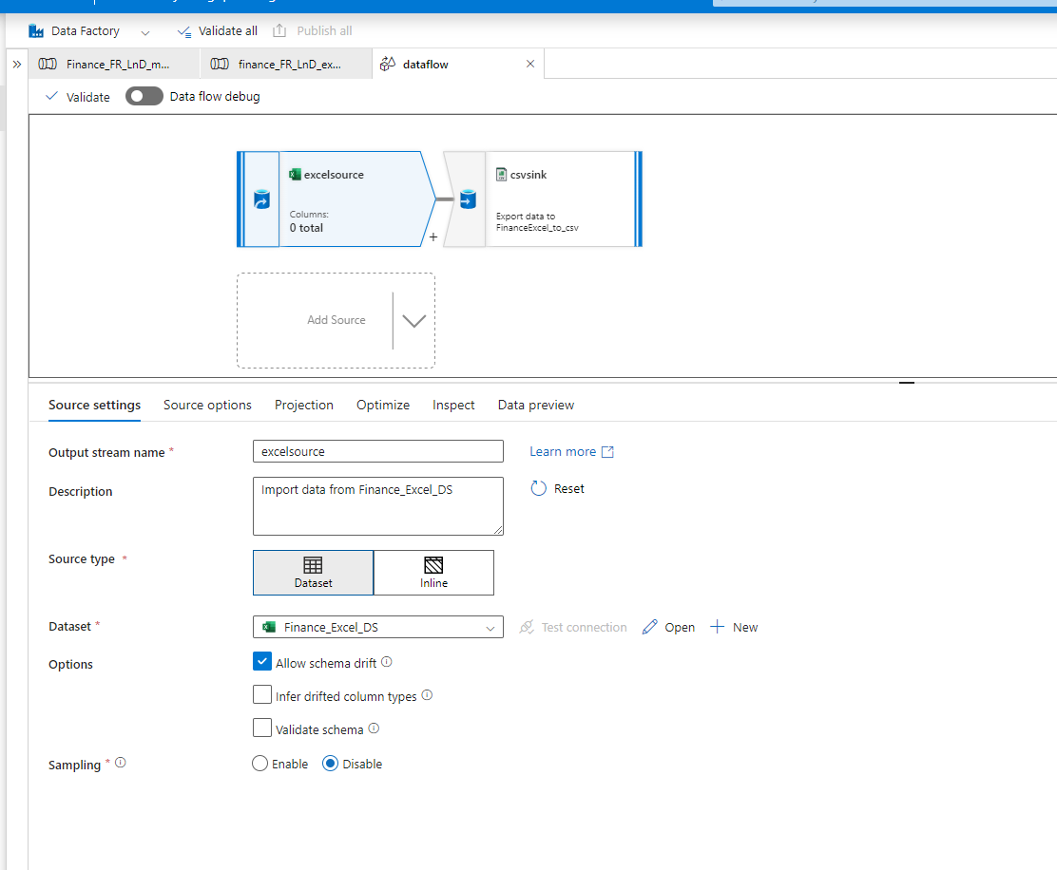
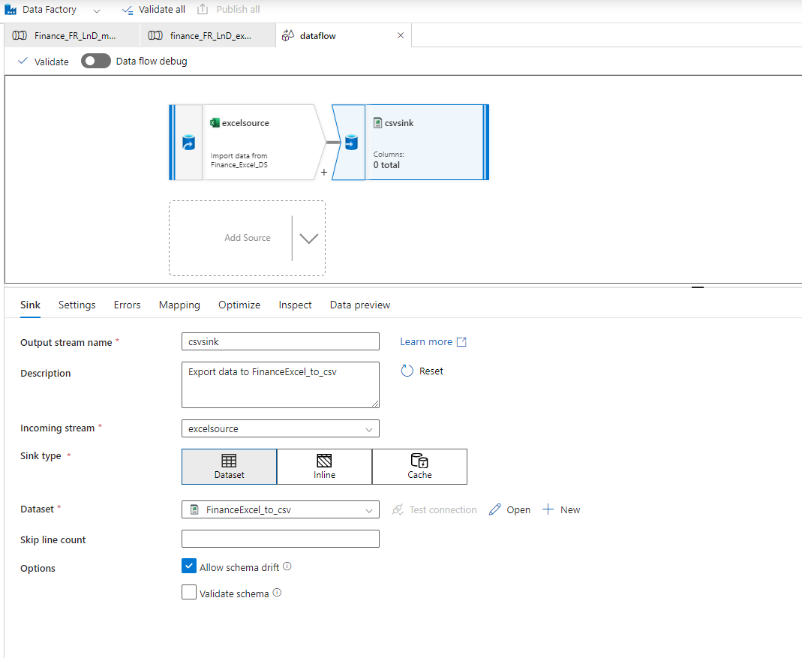

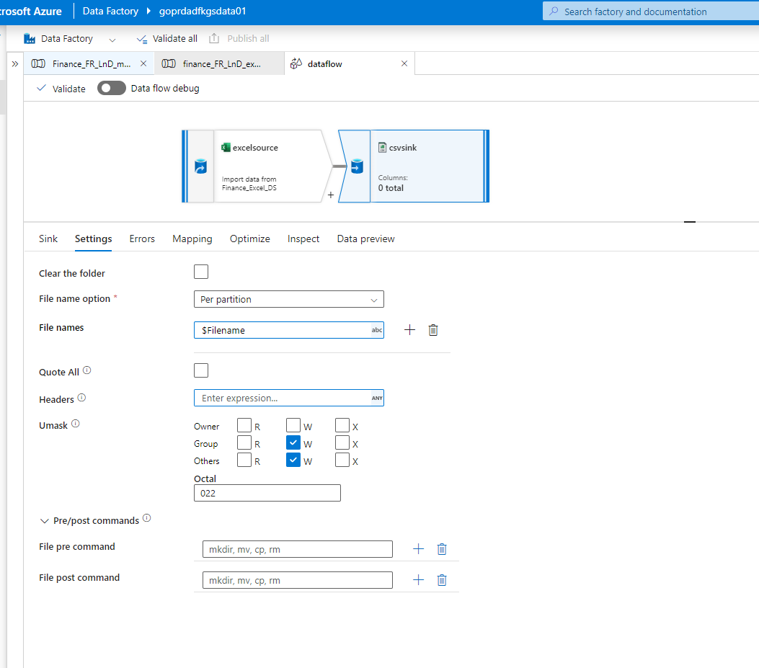
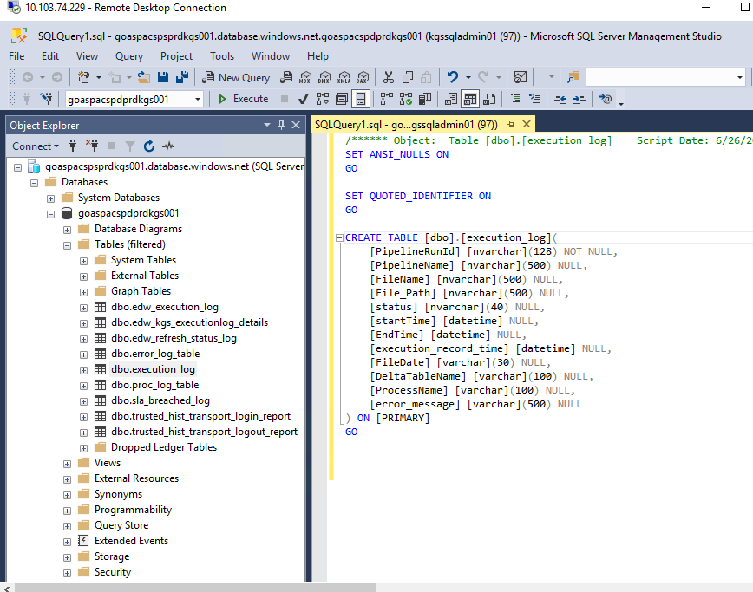

create procedure [dbo].[check_dependency]
(@delta_table_name as varchar(100), @process_name as varchar(100), @file_date as varchar(20))
--,@status varchar(50) OUTPUT

as

declare @count_dependency int
declare @count_dependency_execution_success int
declare @prev_file_process_status varchar(30)
declare @prev_file_process_count int
--declare @status varchar(50)

select @count_dependency = count(1) from [dbo].[CONFIG_SCRIPT_DEPENDENCY_TABLE] where FileName = @delta_table_name and ProcessName = @process_name and Dependency is not null

select @count_dependency_execution_success = count(1) from [dbo].[execution_log] A
left join [dbo].[CONFIG_SCRIPT_DEPENDENCY_TABLE] B
on A.DeltaTableName = B.Dependency and A.ProcessName = B.dependency_process_name
where A.status = 'success' and
-- A.filedate = @file_date and
cast(A.startTime as datetime) in (select max(cast(E.startTime as datetime)) from [dbo].[execution_log] E
where E.DeltaTableName = B.Dependency and E.ProcessName = B.dependency_process_name and
cast(E.FileDate as date) between DATEADD(day,B.dependency_load_frequency,cast(@file_date as date)) and DATEADD(day,B.dependency_load_frequency_max,cast(@file_date as date))) and
B.FileName = @delta_table_name and B.ProcessName = @process_name and B.Dependency is not null

select @prev_file_process_status = status, @prev_file_process_count = count(1) from (select rank() over (partition by processname, filename, filedate order by created_date desc) as status_rank, * from config_file_processing_status) config_file_processing_status where status_rank = 1 and lower(ProcessName) = lower(@process_name) and lower(FileName) = lower(@delta_table_name) and ((lower(Status) = 'inprogress' and (cast(FileDate as date) <= cast(@file_date as date))) or (status = 'failed' and cast(FileDate as date) < cast(@file_date as date))) group by Status

if (
(@count_dependency = @count_dependency_execution_success)
and
(
(@prev_file_process_status = 'failed' and @prev_file_process_count = 0)
or
(@prev_file_process_status = 'inprogress' and @prev_file_process_count = 1)
or
(@prev_file_process_status = '' or @prev_file_process_count is null)
)
)

select 'completed' as status
else
select 'running/pending' as status

create procedure [dbo].[check_prev_load_status]
(@delta_table_name as varchar(100), @process_name as varchar(100), @file_date as varchar(20))
--,@status varchar(50) OUTPUT

as

declare @prev_exec_log_file_process_count int
declare @prev_file_process_status varchar(30)
declare @prev_file_process_count int
declare @prev_child_file_process_status varchar(30)
declare @prev_child_file_process_count int

select @prev_exec_log_file_process_count = count(1) from (select rank() over(partition by deltatablename, processname order by filedate desc, starttime desc) as status_rank,* from execution_log where PipelineName not in ('Main_Pipeline_Load_Excel','Main_Pipeline_Load_Excel_History') and DeltaTableName in (select replace(TargetFileName,' ','_') as TargetDeltaTableName from dbo.config_table_excel_to_csv where lower(ProcessName) = lower(@process_name) and lower(SourceFileName) = lower(@delta_table_name))) A where status_rank = 1 and lower(A.ProcessName) = lower(@process_name) and (status = 'inprogress' or (status = 'failed' and (cast(FileDate as date) < cast(@file_date as date))))

select @prev_child_file_process_status = status, @prev_child_file_process_count = count(1) from (select rank() over (partition by processname, filename, filedate order by created_date desc) as status_rank, * from config_file_processing_status) config_file_processing_status where status_rank = 1 and lower(ProcessName) = lower(@process_name) and lower(FileName) in (select replace(TargetFileName,' ','_') as TargetDeltaTableName from dbo.config_table_excel_to_csv where lower(ProcessName) = lower(@process_name) and lower(SourceFileName) = lower(@delta_table_name)) and ((lower(Status) = 'inprogress' and (cast(FileDate as date) <= cast(@file_date as date))) or (status = 'failed' and cast(FileDate as date) < cast(@file_date as date))) group by Status

select @prev_file_process_status = status, @prev_file_process_count = count(1) from (select rank() over (partition by processname, filename, filedate order by created_date desc) as status_rank, * from config_file_processing_status) config_file_processing_status where status_rank = 1 and lower(ProcessName) = lower(@process_name) and lower(FileName) = lower(@delta_table_name) and ((lower(Status) = 'inprogress' and (cast(FileDate as date) <= cast(@file_date as date))) or (status = 'failed' and cast(FileDate as date) < cast(@file_date as date))) group by Status

if ((@prev_exec_log_file_process_count = 0)
and
(
(@prev_file_process_status = 'failed' and @prev_file_process_count = 0)
or
(@prev_file_process_status = 'inprogress' and @prev_file_process_count = 1)
or
(@prev_file_process_status = '' or @prev_file_process_count is null)
)
and
(
(@prev_child_file_process_status = 'failed' and @prev_child_file_process_count = 0)
or
(@prev_child_file_process_status = 'inprogress' and @prev_child_file_process_count = 1)
or
(@prev_child_file_process_status = '' or @prev_child_file_process_count is null)
)
)
select 'proceed' as status
else
select 'wait' as status

CREATE procedure [dbo].[update_edw_execution_log]
(@PipelineRunId as varchar(100), @PipelineName as varchar(100),@ProcessName as varchar(100),@SourceTableName as varchar(100), @FileName as varchar(100), @FilePath as varchar(100), @record_count as bigint,@status as varchar(20), @startTime as datetime, @EndTime as datetime, @execution_record_time as datetime, @FileDate as varchar(100),@Error_Message as varchar(500))
as
IF(@status = 'inprogress')
insert into dbo.edw_execution_log values(@PipelineRunId, @PipelineName,@ProcessName,@SourceTableName, @FileName, @FilePath,@record_count, @status, @startTime, @EndTime, @execution_record_time, @FileDate,@Error_Message)
ELSE IF (@status = 'success' or @status = 'failed')
update dbo.edw_execution_log set status = @status, error_message = @Error_Message, EndTime = @EndTime where PipelineRunId = @PipelineRunId

CREATE procedure [dbo].[update_execution_log]
(@PipelineRunId as varchar(100), @PipelineName as varchar(100), @FileName as varchar(100), @FilePath as varchar(100), @status as varchar(20), @startTime as datetime, @EndTime as datetime, @execution_record_time as datetime, @FileDate as varchar(100), @DeltaTableName as varchar(100), @ProcessName as varchar(100), @Error_Message as varchar(500))
as
IF(@status = 'inprogress')
insert into dbo.execution_log values(@PipelineRunId, @PipelineName, @FileName, @FilePath, @status, @startTime, @EndTime, @execution_record_time, @FileDate, @DeltaTableName, @ProcessName, @Error_Message)

ELSE IF (@status = 'success' or @status = 'failed')
update dbo.execution_log set status = @status, error_message = @Error_Message, EndTime = @EndTime where PipelineRunId = @PipelineRunId
update dbo.config_file_processing_status set status = @status, Updated_Date = SWITCHOFFSET(GETDATE(), '+05:30') where ProcessName = @ProcessName and FileName = @DeltaTableName and FileDate = @FileDate and FileType = (SELECT value FROM STRING_SPLIT(@FileName,'.',1) where ordinal = 2) and Created_Date = (select max(Created_Date) from config_file_processing_status where ProcessName = @ProcessName and FileName = @DeltaTableName and FileDate = @FileDate and FileType = (SELECT value FROM STRING_SPLIT(@FileName,'.',1) where ordinal = 2))

update dbo.config_table set LastReceived_FileDate = @FileDate where Process_Name = @ProcessName and File_Name = @DeltaTableName and Frequency is not null

